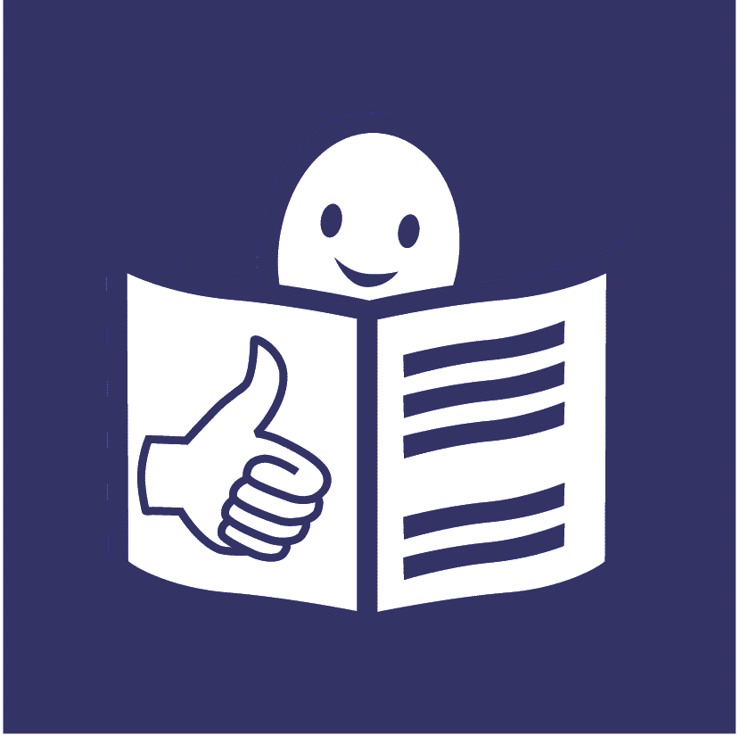

**Left out**

**Problems with education for people with disabilities in Russia**



**Who are we?**

We are called Human Rights Watch.



We work to make sure everyone in the world is treated fairly and gets their rights.

**What is this report about?**



This report is about education for people with disabilities in Russia.

We looked at what is happening with this.

We spoke to lots of people with disabilities, families, the government and other people.



This report tells you:

* what is happening
* what we think should happen next

**What is happening in Russia?**



Many children with disabilities in Russia do not get a good education.

Some children with disabilities get no education at all.

**Special schools**

E:\images\To zip\services.wmf

Many children who do get an education have to go to special schools.

These schools are often far away from home.



This can be hard for children with disabilities and their families.

**E:\images\To zip\learning disability.wmf**

Children in special schools may not learn the same things as other children.

The law says children with disabilities can go to the same schools as other children.

But they often have to go to special schools.

This may be because:

* schools say no to them



* school buildings are hard to get into



* teachers and staff do not have the right skills to support them



* staff tell parents that their child should go to a special school.

Many parents think they have to do what these people say

* E:\images\To zip\learning disability.wmfchildren and their parents do not get good information about their rights and choices

**Staying at home**

Some children with disabilities stay at home to study.



The law says they can study at home if they want.



But many children with disabilities

do not have much choice.

For example, they may find it hard to leave the house because:

* there are no lifts or ramps in their building
* transport is hard to use



Teachers visit these children at home but only a few times a week.



Many children said they find this difficult and that they feel alone.

**Homes for children with disabilities**

Many children with disabilities do not live with a family.

They live in homes with other children. They are looked after by staff.



Some children in these homes get a bit of education. But many do not.



There can be many reasons for this.

For example:

* there are not enough teachers in the homes



* the homes are far away from the rest

of the community



* staff put some children with disabilities into rooms where they have to lie down all day

**Education at university**

It can be hard for young people with disabilities to get a good education at places like university.



This may be because:

* they did not get a good education at school first



* staff cannot support them in the right way



All of this means that

many people with disabilities do not get a good education.

This can cause big problems later on.

For example, it can be harder for them to get a job or be part of their communities.

**What the government is doing**

The law in Russia says that every child has the right to an education.



The government also agreed

that everyone with disabilities should get:

* a good education in their community like everyone else

E:\images\To zip\support.wmf

* the support they need to do well

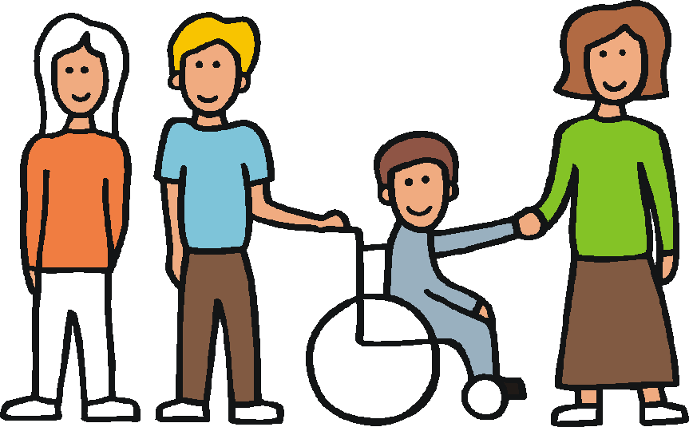The government is changing the laws and rules about education.

This is to make sure all children get a good education.

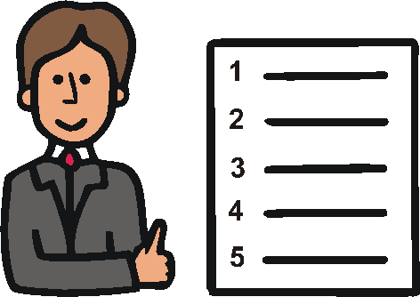Some things are changing.

For example it is now easier

for children with disabilities to go to some schools.

But there is still much more to do.

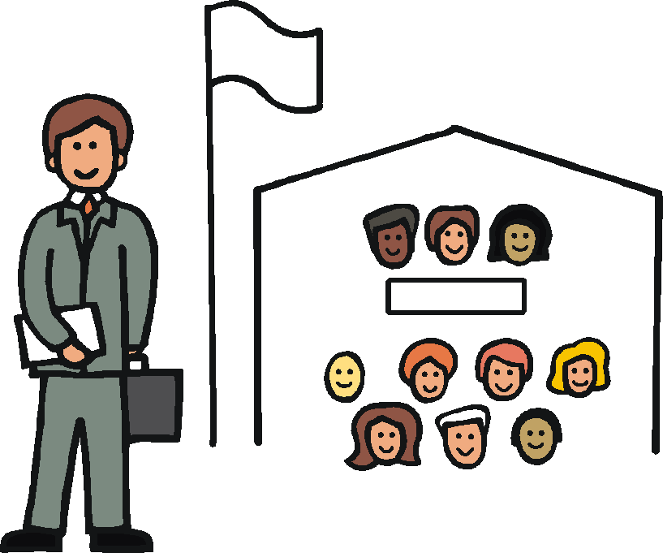**What should happen next**

We want the government in Russia to make sure that **all** people with disabilities can:



* get a good education in the same places as people without a disability



* mix with other children and learn the same things together

E:\images\To zip\support.wmf

* get the support they need to do well.

This may be support to learn or other things they need

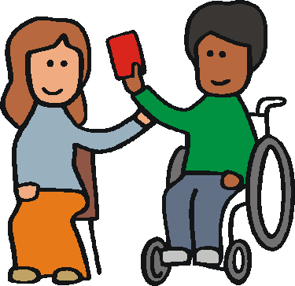

* have a real choice about their education

The government in Russia should make sure that people with disabilities:



* are not forced to stay at home because of problems leaving their building or bad transport



* are not shut in homes far away from their community



* get good information about their rights



* know what to do if they do not get their rights

E:\images\To zip\meeting room.wmf

* can have a say in what the government does about education

The government in Russia should also make sure that:

* laws and rules say the right things about education for people with disabilities

E:\images\To zip\support.wmf

* teachers and staff have the right skills and training to support people with disabilities



* schools have enough money to support people with disabilities in the right way



* school buildings are easy for people with disabilities to use



* people with disabilities get information and support about jobs

The government in Russia should also make sure that:

* people are checking to make sure education for people with disabilities is getting better

:



* there is good information about

people with disabilities in school



* schools can get in trouble if they say no to children with disabilities



* more people in Russia know about what people with disabilities can do



We also think that other countries should help Russia do what they need to do.

Pictures The Picture Communication Symbols ©1981–2013 by DynaVox Mayer-Johnson LLC.  All Rights Reserved Worldwide.  Used with permission.