
Once you enter, you never leave

A report about
people with an intellectual disability or a mental health problem in Croatia

September 2010


What we think needs to happen

Easy to read

Who are we?

We are called Human Rights Watch.



We work to make sure people everywhere
are treated fairly.

What is this report about?


This report is about a country called Croatia.

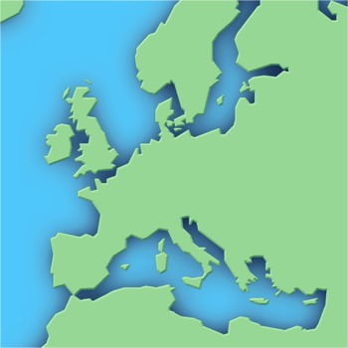
Croatia is in Europe.

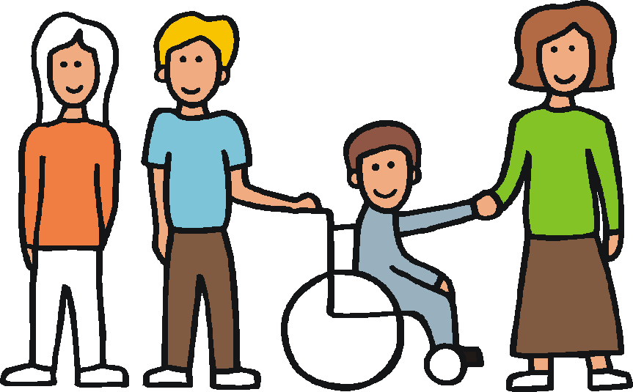
It is about people in Croatia who have an intellectual disability or a mental health problem.


This report talks about
- what life is like for these people in Croatia
- what we think needs to change.


What is life like in Croatia?

Life can be hard for people with an intellectual disability
or a mental health problem.

Many people live in special homes or hospitals.

These homes may be far away from other places.

It can be hard for people living there to
- do the same things as other people
- get out and about
- meet other people
- make their own choices.

Some people live in these homes
because they cannot get the right support
near where they live.

But many people have no choice.

Other people decide for them.

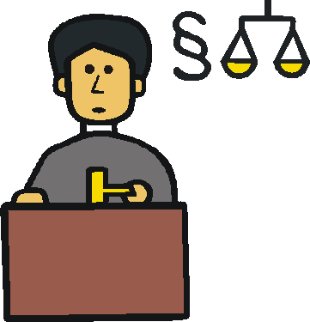

The law says they can do this.

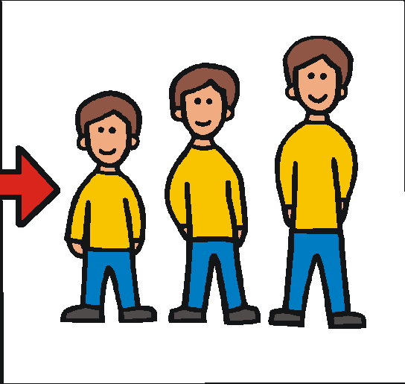

Most people stay in these homes
for the rest of their lives.

This means they do not have the same rights
as other people.

And they cannot do the things they want or enjoy.

What is the government

in Croatia doing?

The government said they will do more
to help people with disabilities.

But this is not happening.

Some people with disabilities in Croatia live in other places.

For example, some people live in apartments on their own or with other people.

They can get support if they need it.

This helps people be part of their local area.
It helps them do the same things as other people.

There is some support like this in Croatia. But not enough.

What does the law say?
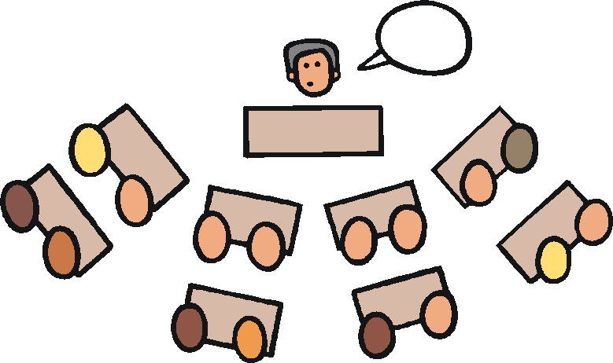

Lots of countries have agreed
to make life better for people with disabilities.

Croatia agreed to this too.

The law says the countries have to do lots of things.

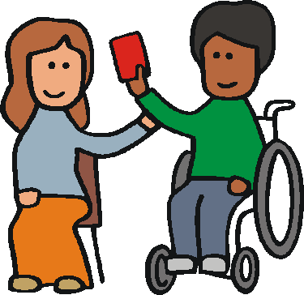

For example, making sure
people with disabilities can choose
where to live and who to live with.

But Croatia is not doing this.

Some other countries are not doing this either.

But Croatia said it would do a lot more for people with disabilities.

Why is this problem happening?


The government in Croatia has less money to spend.

This is because of big money problems
in the world.

But that is not the only reason.
The government has not made any plans
to help people live in better places.

This means nothing is changing.

It is not easy to move people
out of these homes.

But it is important. It means they can have a better life.

And it costs less money than keeping people in the homes.


What needs to happen next?

Here are some things we think
the government in Croatia needs to do.

1. Make good plans. The plans should say
how people with disabilities can move out
of the homes and have better lives.

2. Not spend more money on homes like this.
The government should spend money
on better places for people to live.
3. Make sure the homes people live in now
are safe while this other work is going on.

4. Make sure there is enough good support
for people near where they live. This support could come from
the government or other groups.

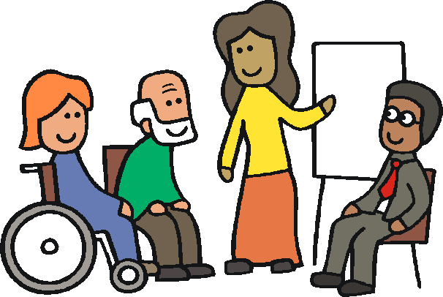
5. Set up a new group of people with disabilities
and other people.

This group can help make sure things are done in the right way.

6. Change the laws that let others make decisions for people with disabilities.
The laws should support people with disabilities
to make their own decisions in a safe way.

7. Change the laws so that
people cannot be put in homes
without them saying yes or having a say.

There should be proper checks
to make sure it is the right thing to do.

This easy to read document was written to the European standards for making information easy to read and understand. www.easy-to-read.eu

