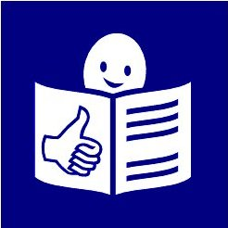
Easy to read

HIV and people with disabilities in Zambia

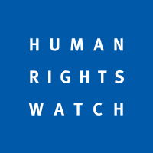
Who are we?

We are Human Rights Watch.

We work to make sure everyone in the world is treated fairly and gets their rights.

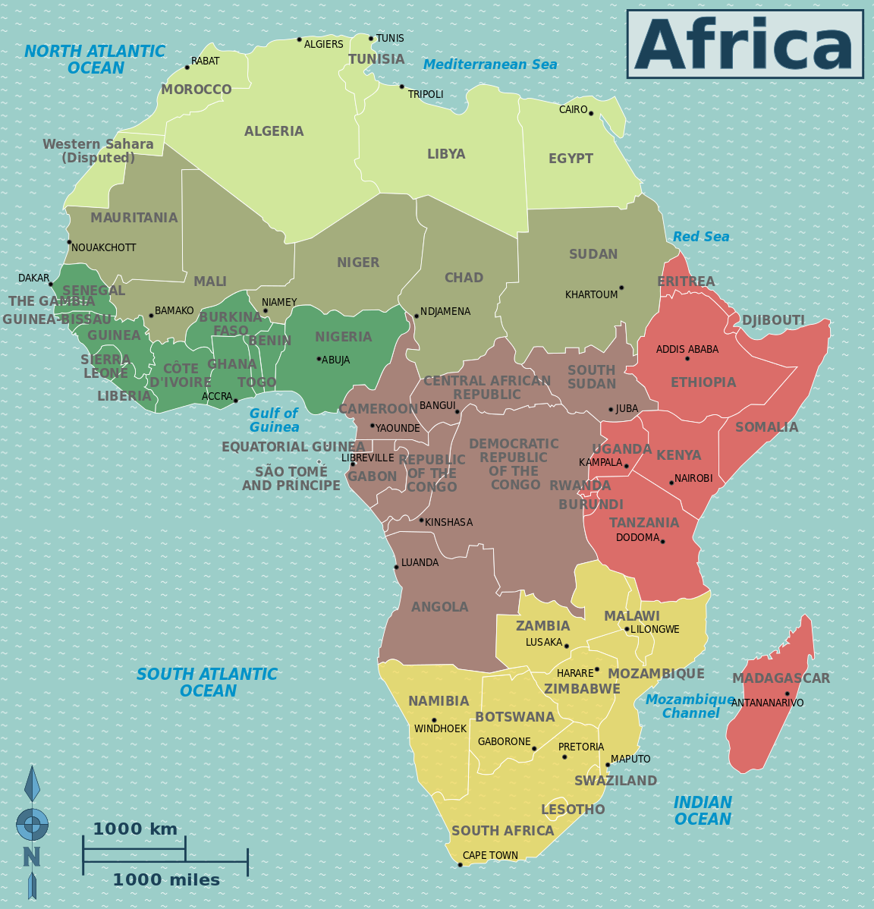
What is this report about?

This report is about people with disabilities in a country called Zambia. Zambia is in Africa.

It talks about people with disabilities in Zambia and HIV.

What is HIV?

HIV is an illness. It is something that happens to your body.

It makes it harder for your body to fight against illness.

People with HIV may get something more serious called AIDS later on.

AIDS is when someone’s body is very weak and cannot fight illnesses.

People can get HIV from things like sex without a condom.

HIV is a big problem in Zambia and other countries in Africa and around the world.

What is life like for people with disabilities in Zambia?

People with disabilities have more chance of getting HIV than other people.

This is because people with disabilities:

- do not get the support they need
- are often treated badly

- may be hurt or forced to do sexual things they do not want

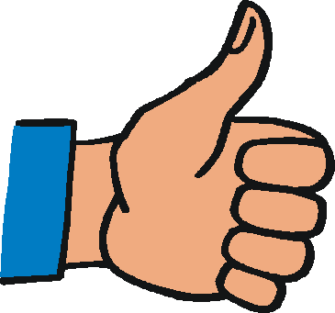

Many people in Zambia now get better care and support for HIV.

But not people with disabilities.

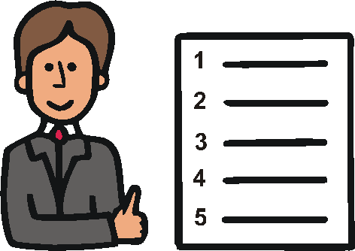
People with disabilities have the same rights as other people to get good health care.

The government in Zambia said they will do much more for people with disabilities.

But this is not happening.

It is much harder for people with disabilities to get the support they need, like:

- good information about how to stop HIV

- condoms to have safe sex

- tests to see if they have HIV

- medical care

- good support
Why do people with disabilities not get the support they need?

- People are treated badly

Many people in Zambia think bad things about disability.

For example, they may think:
- it is bad to have a disability
- people with disabilities should not have sex

This can stop people with disabilities from getting the support they need to be safe from HIV.

- People do not get good information

Children with disabilities often do not go to school.

This means they cannot get good information about how to stop HIV.

It is hard for people with disabilities to get help because of things like:

- information that is hard to understand

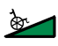
- staff who do not know how to work with people with disabilities

- places that are hard to get to and buildings that are hard to get into

Many women and girls with disabilities are forced to do sexual things they do not want to do.

They need better information and support to keep them safe from HIV.

- It is harder to get tests and good medical care

It is harder for people with disabilities to get the right care if they may have HIV.

This is things like:
- tests to see if they have HIV
- medicine
- information and support

Health staff often do not know what people with disabilities need or how to talk to them.

Health staff do not always make sure that people:
- understand the care they get
- agree to what is happening

- People do not get the right support to take medicine

People can get medicine and care for HIV from places like hospitals.

But people with disabilities can find it hard to get there unless they have someone to help them.

Some things can make it easier for people with disabilities.

For example, health staff can give people with disabilities enough medicine if they cannot get to the clinic often.

But health staff often do not make things easier for people with disabilities.

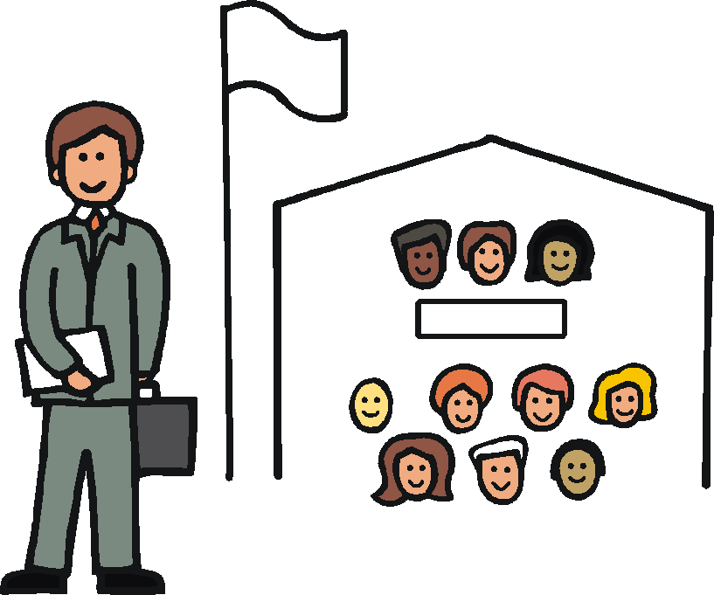
What we think needs to happen

These are things for the government in Zambia and others to do:

- Make sure the government does what the law says for people with disabilities.

The law says people with disabilities should be treated fairly and get their rights.

2. Make sure all people with disabilities get support that is right for them.

3. Make hospitals and health places easier for people with disabilities to use.

Make sure staff have good training in sign language to help them talk to deaf people.

What we think needs to happen

4. Make some rules for health staff about treating people with disabilities fairly when they get tests and support for HIV.

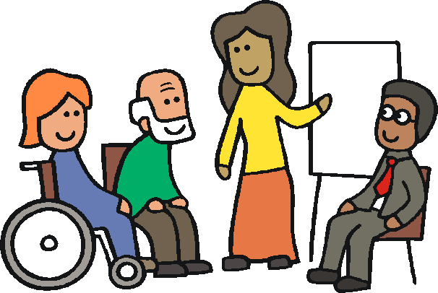

Give health staff training about how to treat people with disabilities fairly.

5. Make sure people with disabilities:
- understand and agree to their care
- get care in a private and safe way

6. Make it easier for people with disabilities to get care at home or near where they live.

7. Do more to keep women and girls with disabilities safe from violence.

What we think needs to happen

8. Do more to stop people with disabilities from being treated badly.

9. Find out more about people with disabilities and HIV.

For example, how many people have HIV and how they get it.

10. Make sure groups around the world help the government in Zambia get things right for people with disabilities.

Daniel’s story

Daniel is 13 years old. He is deaf and cannot hear.

Both his parents died of HIV.

Daniel also has HIV.

The rest of Daniel’s family treated him badly.

They thought Daniel was bad because he had a disability and HIV.

Daniel cannot talk to anyone about his HIV.

People do not know how to talk to him using sign language.
He is scared to tell his school friends.

Daniel is worried about the future. But he told us that he is strong and will keep fighting.
This easy to read document was written to the European standards for making information easy to read and understand. www.easy-to-read.eu

