
Information about Gender-Based Violence for People with Disabilities

Places to get help in Zambia

In Zambia there is a law called the Anti-Gender Based Violence Act.

It says you can get help if someone does very bad things to you.

There are places called one stop centers that give you help with your health and the law all in one place.

Police stations have special police men and women to help you. They work in the Victim Support Unit at your local police station.
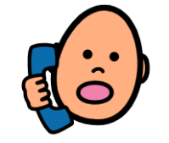 | Free helplines you can call at any time in the day or night
Name | What it does | Number
CHAMP Hot-line | They can give you information and support about your health. | Hotline: 999
Lifeline | They help adults. They can help you if someone is hurting you or doing bad things to you. | Hotline: 933
CHILD-LINE | They help children who need any kind of help. They can help you quickly if you need it. | Hotline: 116
 | Groups that help with the law
Name | What they do | Address, Number
Legal Aid Board Zambia | They can give you free information and support with the law. | 1st Floor, New Kent Building.  Haile Selassie Ave,  P.O Box 32761  Lusaka Zambia  Telephone:  +260 211 256 453;  +260 211 256 454
National Legal Aid Clinic for Women | They give information and support to women and children. | Musonda Ngosa Road 110A/150 Villa Elizabetha, Lusaka  Telephone:  +260 211 220 595
Legal Resources Foundation | They can help you with paying for things like going to court. | Woodgate House Cairo Road, Lusaka
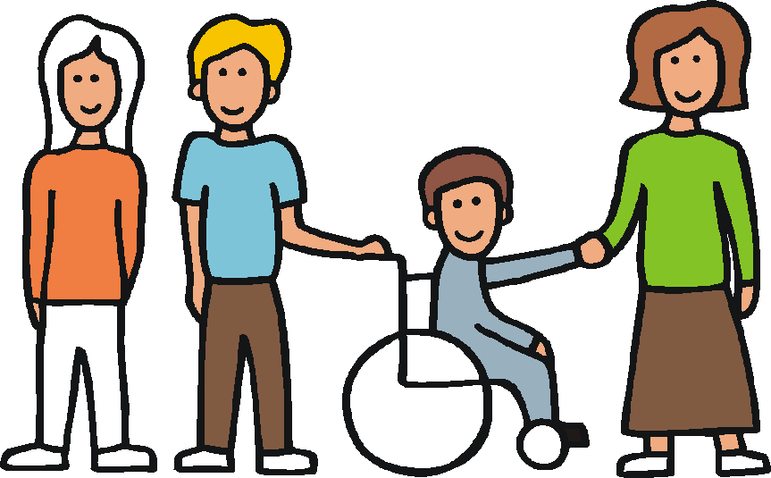 | Groups that help people with disabilities
Name | What they do | Address, Number, Website
Zambia Federation of Disability Organizations (ZAFOD) | They help people with disabilities. | Plot 6867, off Katima Mulilo Road along Chainama  Road Olympia, Lusaka, Zambia  Telephone:  +260 211 295 831; +260 978 960 412  http://www.zafod.org.zm
Zambia Agency for Persons with Disabilities | They are part of the government. They help people with disabilities. | Plot No, 488 /7B  Leopards Hill Road  Kabulonga, Lusaka
Zambia National Federation of the Blind | They help people who cannot see. | Plot No. 4225, Along Chilumbulu Road, Chilenje, Lusaka  Telephone:  +260 211 253 180
Name | What they do | Address, Number, Website
Zambia HIV/Disability Human Rights Programme (ZAMDHARP) | They help people with disabilities and HIV. | Telephone:  +260 977 566 763
Zambia Deaf Youth and Women | They support people who cannot hear. | SMS on:  +260 977 866 459  New Nakadoli Market,  Copperbelt Province  Kitwe  zambiadeafyw@zambia.co.zm
Mental Health Users Network of Zambia (MHUNZA) | They help people with a mental health difficulty. | Plot 47/D Mansa Road, Emmasdale  Lusaka  Telephone:  +260 978 818 600
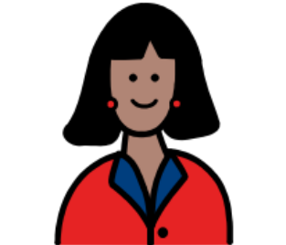 | Women’s groups and other groups
Name | What they do | Address, Number, Website
Women and Law in Southern Africa – Zambia (WLSA Zambia) | They help people with things like:  - paying for court  - women’s health | Joseph Mwila Road Rhodes Park, Lusaka.  Telephone:  +260 211 294 989  www.wlsazambia.org
Women in Law and Development in Africa (WiLDAF) | They give women and girls information about the law. They work to stop violence. | No. 26, Nalubutu Rd.  Long Acres  Lusaka, Zambia  Telephone:  +260 211 251 491;  +260 211 251 497
Name | What they do | Address, Number, Website
Young Women’s Christian Association of Zambia (YWCA Zambia) | They help women and girls who are being hurt or who may be in danger. They give people a safe place to stay. | ywca@zamnet.zm  Along Nationalist Road, opposite University Teaching Hospital,  Lusaka.  Telephone:  +260 211 255 204; +260 211 254 751
World Vision Zambia | They work to stop violence.  They help women and girls who are being hurt. | Telephone:  +260 211 221 955  http://www.wvi.org/zambia
Population Council | They work to stop violence. | Telephone:  +260 211 295 925  http://www.popcouncil.org/research/zambia
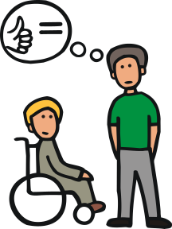 | One Stop Centres. These are places to get help with your health, the law and other support
Province | One Stop Centre | Phone number
Western Province | Mongu Urban Clinic | +260 977 429 530
Lusaka | Chongwe Hospital | +260 950 420 091; +260 966 981 472; +260 977 848 487
Lusaka | University Teaching Hospital Centre of Excellence | +260 979 495 095
Lusaka | Ng’ombe Health Centre (Lusaka) | +260 977 864 098
Lusaka | Kafue District Hospital | +260 977 465 240
Lusaka | Mutendere Clinic (Lusaka) | +260 97 962 3318
Lusaka | Chawama Clinic (Lusaka) | +260 978 129 614
Muchinga | Nakonde Urban Clinic | +260 967 608 727; +260 967 710 785
Muchinga | Mpika Urban Clinic | +260 977 815 464
Southern | Choma Urban Clinic | +260 978 904 949; +260 964 414 402;  +260 964 414 400;  +260 955 988 203
Southern | Kalomo Hospital | +260 971 252 324
Southern | Monze District | +260 979 952 520
Southern | Livingstone General Hospital | +260 977 828 128
Southern | Mazabuka District Hospital | +260 978 875 005
Central | Kapiri Mposhi Urban Clinic | +260 977 713 575
Central | Mumbwa Urban Clinic | +260 977 939 484
Central | Chiboko Clinic | +260 966 100 870
Province | One Stop Centre | Phone number
Eastern | Nyimba District Hospital | +260 977 876 943; +260 955 923 677; +260 965 923 677
Eastern | St. Francis Hospital (Katete) | +260 963 572 260;  +260 977 440 994
Eastern | Chipata General Hospital | +260 964 441 751
Copperbelt | Kabundi Clinic (Chingola) | +260 979 272 519
Copperbelt | Thomson Hospital (Luanshya) | +260 966 826 939
Copperbelt | Ndola General Hospital | +260 966 905 200
Copperbelt | Buchi Clinic | +260 977 997 725
Copperbelt | Kabwe Hospital | +260 977 498 353

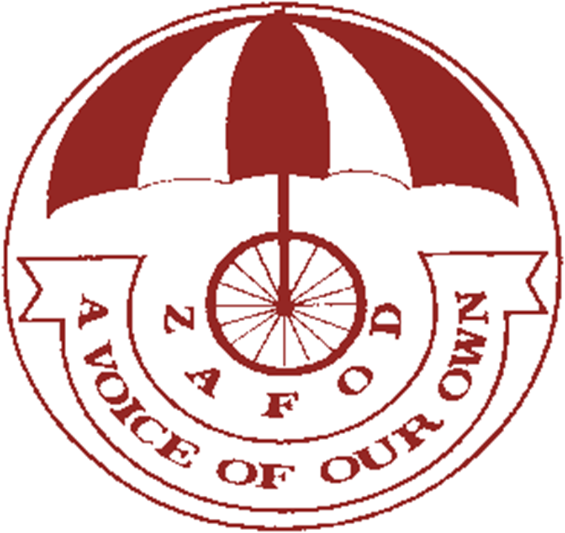


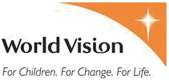
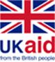


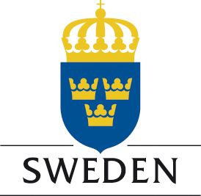

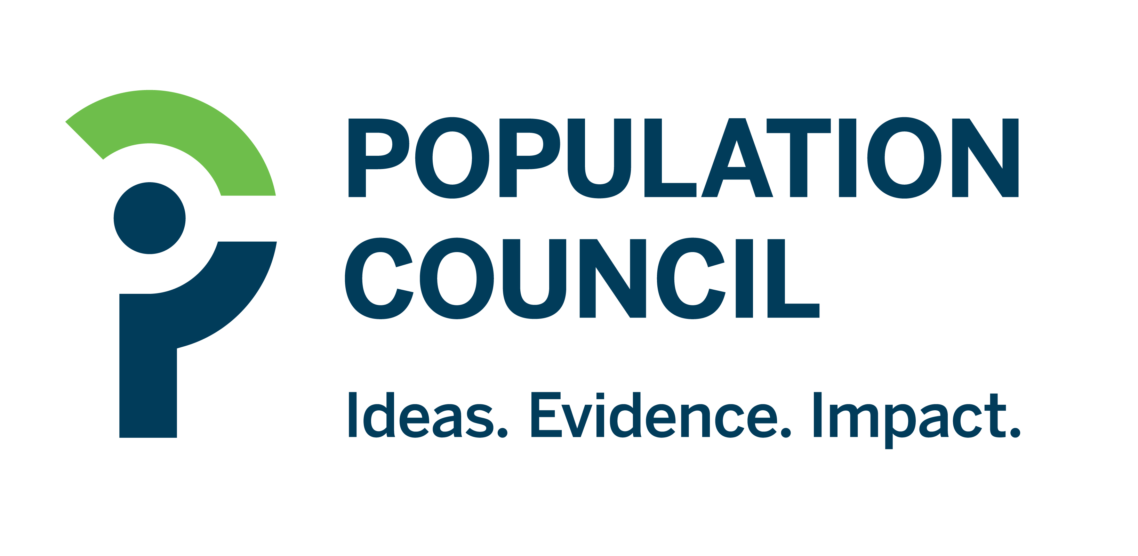
P

Pictures: The Picture Communication Symbols ©1981–2013 by DynaVox Mayer-Johnson LLC. All Rights Reserved Worldwide. Used with permission.
Other pictures The Picture Communication Symbols ©1981–2013 by DynaVox Mayer-Johnson LLC. All Rights Reserved Worldwide. Used with permission.

Other pictures The Picture Communication Symbols ©1981–2013 by DynaVox Mayer-Johnson LLC. All Rights Reserved Worldwide. Used with permission.

Other pictures The Picture Communication Symbols ©1981–2013 by DynaVox Mayer-Johnson LLC. All Rights Reserved Worldwide. Used with permission.

Other pictures The Picture Communication Symbols ©1981–2013 by DynaVox Mayer-Johnson LLC. All Rights Reserved Worldwide. Used with permission.

Other pictures The Picture Communication Symbols ©1981–2013 by DynaVox Mayer-Johnson LLC. All Rights Reserved Worldwide. Used with permission.

